**Project 1: Sales Data Analysis and Dashboard (Excel/Power BI)**

**1. Executive Summary**

This project presents a comprehensive **sales data analysis** using Power BI, based on the popular **Superstore Dataset**. The goal was to uncover actionable business insights, monitor key performance metrics, and build a dynamic dashboard to assist decision-makers in understanding patterns such as sales trends, regional performance, product profitability, and customer segmentation.

We began with raw sales data and performed essential cleaning and transformation in Excel. The cleaned dataset was imported into Power BI, where we developed multiple visualizations that allow stakeholders to explore patterns in revenue generation, seasonal fluctuations, and regional performance. Our final dashboard delivers real-time filtering, drill-down capabilities, and clear data storytelling.

**2. Project Objective**

To:

* Analyze a company’s historical sales data to understand **key revenue drivers**.
* Identify **seasonal trends**, top-performing **customers**, **products**, and **locations**.
* Uncover areas of **profit leakage** and recommend improvement strategies.
* Build an **interactive Power BI dashboard** for exploration and decision-making.
* Provide a **summary report** with findings and business recommendations.

**3. Dataset Description**

The project uses the **Superstore Sales Dataset**, a retail dataset simulating transactions for a US-based store. Below is a description of the dataset columns:

| **Column Name** | **Description** |
| --- | --- |
| Row ID | Unique row index (not used for analysis) |
| Order ID | Unique ID per transaction |
| Order Date | Date when the order was placed |
| Ship Date | Date when the product was shipped |
| Ship Mode | Shipping method (e.g., First Class, Second Class) |
| Customer ID | Unique ID per customer |
| Customer Name | Name of customer |
| Segment | Customer segment (Consumer, Corporate, Home Office) |
| Country | Country (all USA) |
| City | City name |
| State | State name |
| Postal Code | ZIP code (used in mapping if required) |
| Region | US region (West, East, South, Central) |
| Product ID | Unique ID for each product |
| Category | Product category (Furniture, Technology, Office Supplies) |
| Sub-Category | Sub-category (e.g., Chairs, Phones, Binders) |
| Product Name | Product name |
| Sales | Revenue from product |
| Quantity | Number of units sold |
| Discount | Discount applied (%) |
| Profit | Net profit after discount |

**4. Data Cleaning Process (in Excel)**

Before importing into Power BI, we performed the following steps in Excel:

1. **Cleaning & Preparation:**

* **Removed duplicate rows** to avoid inflated KPIs.
* Checked for **missing values** — none found.
* Formatted **Order Date** and **Ship Date** to valid Excel dates.

1. **Column Transformation:**

* Created new columns:
  + **Year** = Extracted from Order Date
  + **Month** = Full month name
  + **Month-Year** = Combined for trend analysis (e.g., Jan 2019)

1. **Dropped Columns (for visuals):**

| **Dropped** | **Reason** |
| --- | --- |
| Row ID | Not meaningful |
| Customer ID / Product ID / Order ID | Kept for backend but not shown in visuals |
| Postal Code | Not needed for our visuals |

**5. Dashboard Design & Visual Explanation (Power BI)**

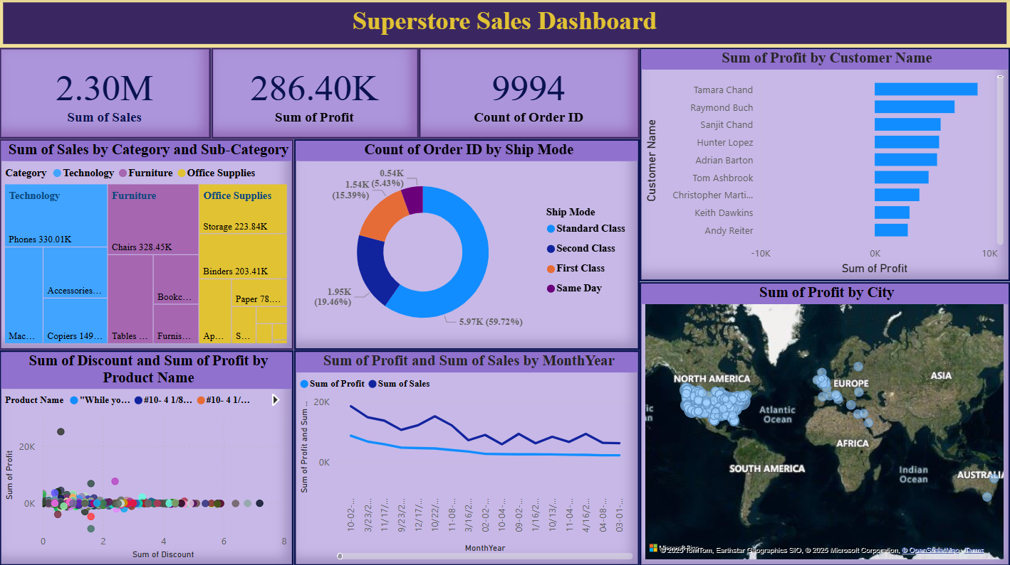

The Power BI dashboard consists of **interactive cards, charts, maps, and slicers** designed for intuitive navigation.

**🔹 1. KPI Cards (Top Panel)**



| **Metric** | **Description** |
| --- | --- |
| **Sum of Sales** | Total revenue (₹2.30M) |
| **Sum of Profit** | Net profit (₹286.40K) |
| **Count of Orders** | Total transactions (9,994 orders) |

➡ **Purpose**: Quickly understand overall performance at a glance.

**🔹 2. Sales by Category & Sub-Category (TreeMap)**

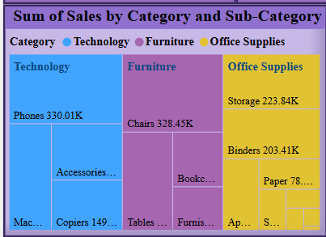

* Visualizes **which categories and sub-categories** contribute the most.
* Example: Technology > Phones contributes the largest share.

➡ **Insight**: Helps optimize inventory and marketing spend.

**🔹 3. Order Volume by Ship Mode (Donut Chart)**

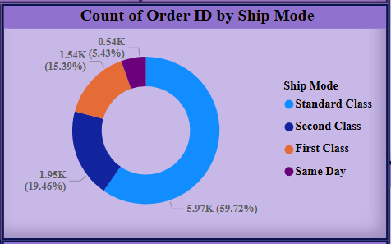

* Most orders are shipped using **Standard Class** (~60%).
* Others include Second Class, First Class, and Same Day.

➡ **Insight**: Optimize logistics and renegotiate with shipping vendors.

**🔹 4. Profit by Customer Name (Bar Chart)**

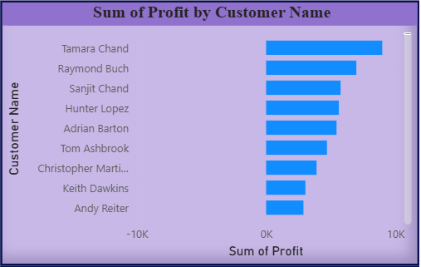

* Ranks customers by total profit contribution.
* Top contributors include **Tamara Chand**, **Raymond Buch**, etc.

➡ **Insight**: Target top customers with loyalty programs or personalized offers.

**🔹 5. Discount vs Profit by Product (Scatter Plot)**

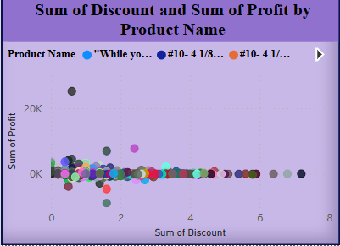

* Plots how different discount levels affect profit by product.
* Observes that high discounts **do not always result in high profits**.

➡ **Insight**: Revise discounting strategy — reduce excessive discounts.

**🔹 6. Monthly Sales & Profit Trend (Line Chart)**

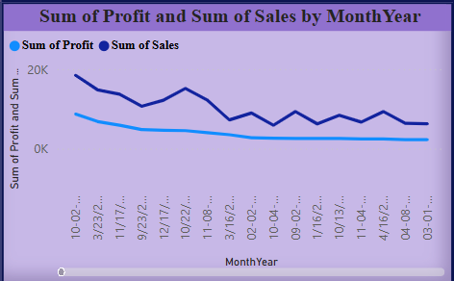

* Visualizes trends over **Month-Year**.
* Peak observed in **November–December**, dips in **mid-year**.

➡ **Insight**: Plan seasonal promotions around peak periods.

**🔹 7. Profit by City (Map Visual)**

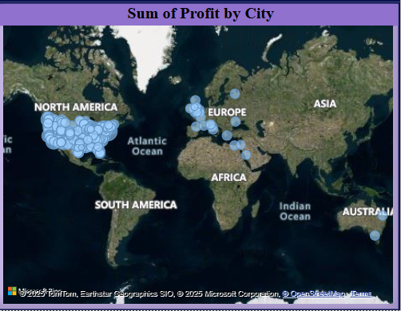

* Displays regional profit contributions.
* Larger blue bubbles indicate **higher profit cities** (e.g., New York, LA).

➡ **Insight**: Focus on **expansion or improvement** in low-profit regions.

**6. Key Insights (From Dashboard)**

| **Insight Area** | **Observation** |
| --- | --- |
| **Product** | Phones & Chairs are top-selling sub-categories |
| **Customer** | Small group of customers contribute disproportionately to profit |
| **Region** | Western US contributes more sales, but some states underperform in profit |
| **Shipping** | Standard Class dominates but may be slower |
| **Seasonality** | Sales and profits peak in November and December |
| **Discounts** | Excessive discounts lower profits – needs monitoring |

**7. Business Recommendations**

| **Area** | **Recommendation** |
| --- | --- |
| **Pricing** | Review and limit discounts that hurt profits |
| **Marketing** | Increase marketing for underperforming but high-potential sub-categories |
| **Customer** | Implement loyalty or referral programs for high-value customers |
| **Shipping** | Improve delivery experience, especially for Standard Class |
| **Expansion** | Consider focusing on high-profit regions for growth |
| **Inventory** | Prioritize stock for fast-moving high-profit items (e.g., Phones, Binders) |

**8. Tools Used**

| **Tool** | **Purpose** |
| --- | --- |
| **Microsoft Excel** | Initial data cleaning, transformation |
| **Power BI Desktop** | Dashboard creation, KPIs, interactivity |
| **DAX (Power BI)** | Custom measures (Profit Margin, Avg Order Value, etc.) |